    Joint Collaborative Team on Video Coding (JCT-VC)  of ITU-T SG 16 WP 3 and ISO/IEC JTC 1/SC 29/WG 11  18th Meeting: Sapporo, JP, 30 June – 9 July 2014 | Document: JCTVC-R0086

Title: | SCCE3 Test C.2: combination of palette coding tools
Status: | Input Document to JCT-VC
Purpose: | Proposal
Author(s) or  Contact(s): | C. Gisquet, G. Laroche, T. Poirier, P. Onno  Canon Research Centre France  Rue de la Touche Lambert  35510 CESSON-SEVIGNE, FRANCE | Tel:  Email: | +33 299876800  christophe.gisquet@crf.canon.fr  patrice.onno@crf.canon.fr
Source: | Canon CRF
_____________________________

Abstract
This contribution reports the results of SCCE3 test C.2 on the combination of palette coding tools from SCCE3 test A.3, B.5, B.6 and B.7, as well as improved encoder algorithms. It is reported that the use of such a prediction method provides gains, compared to SCCE3 palette anchor, of -6.6% (AI) / -4.3% (RA) / -2.9% (LDB) with IBC search area of 2 CTBs, and -4.7 % (AI) / -3.1% (RA) / -2.4% (LDB) with IBC search on the full frame.

Description
The list of normative tools is as follows:
- Test A.3 on palette stuffing: the unused palette entries of the predictor for a palette-codec CU are put the end of the predictor for reuse in predicting the next palette-coded CU;
- Test B.5 on index coding: given the number of entries and given the previous prediction mode, it is possible to infer a list of possible palette entries and adapt the index coding, here using truncated binary codes;
- Test B.6 on transition prediction: in this mode, given the palette index of the previous pixel, it is possible to determine the most probable palette index following and use it to more effectively code the effective index;
- Test B.7: although run coding accounts for runs of a single index, it is possible to determine at the CU-level which indexes should never use run coding.
The encoder algorithm, a close parent to the K-means method, can be described as follows:
- For every pixel, the best palette entry among the ones currently stored is determined and:
  - If said entry and pixel do not match sufficiently, the pixel value is added as a new entry;
  - Otherwise, there is a match and statistics are accumulated so as to update the palette entry with the average/centroid of the pixels.
- For each palette entry, until MAX_PLT_SIZE have been selected:
  - Predictor matching (also present in tests A.6 and C.4): replacing a palette entry with a specific palette predictor entry has a cost and based on the best cost, it is possible to determine whether to replace the palette entry, and by which predictor entry.
  - Find and remove duplicated entries if they exist (this may cause issues with signalling or an unsuspecting decoder);
- If any pixel still needs to be escape-coded given the current palette entries, it is added to the palette entries until the palette size reaches its maximum.

Results

2 CTBs IBC search
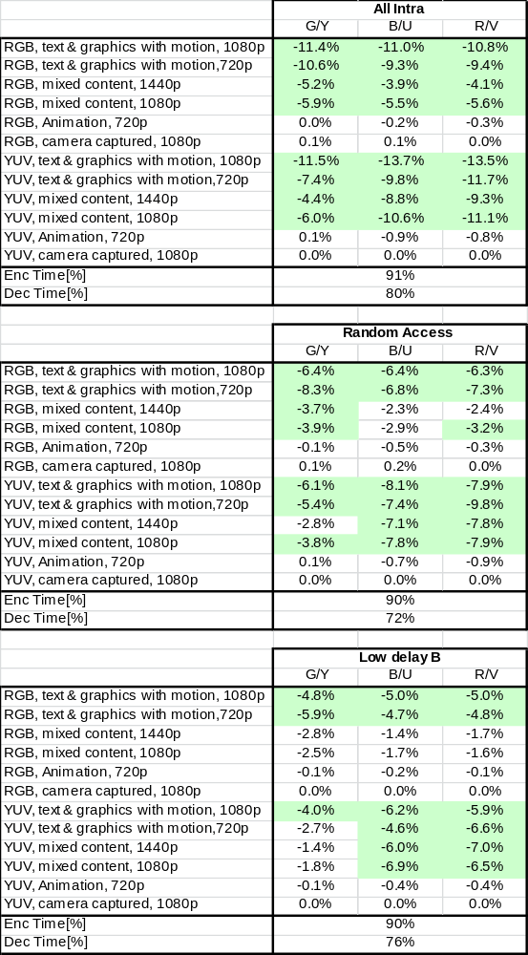

Full frame IBC search
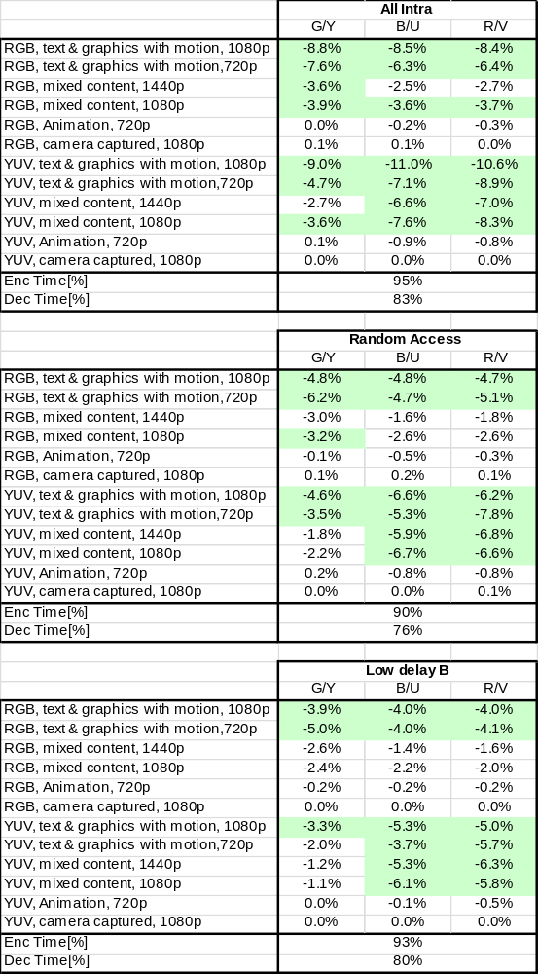

Conclusion

Patent rights declaration(s)
Canon Research Centre France may have current or pending patent rights relating to the technology described in this contribution and, conditioned on reciprocity, is prepared to grant licenses under reasonable and non-discriminatory terms as necessary for implementation of the resulting ITU-T Recommendation | ISO/IEC International Standard (per box 2 of the ITU-T/ITU-R/ISO/IEC patent statement and licensing declaration form).

